DEDUCE Simulated Operating Characteristics of Phase 1 Dose Escalation Designs
Report Date and Time: 2021-05-20 11:11:00
Software: DEDUCE app version 1.0 available here

Objective:
To evaluate the operating characteristics of the following dose escalation design(s): 3+3, TARGET-CRM, CRM

Methods:
Trial operating characteristics are averaged over 100 simulated trials. Simulated trials have 4 dose levels labeled -1,1,2,3, starting on dose level 2, and assume true toxicity probabilities of 0.05,0.12,0.2,0.3. The target toxicity probability is 0.2. One patient enrolls every 15 days on average. The DLT observation period is 28 days.
For the TARGET-CRM and/or CRM design, the prior toxicity probabilities per dose level are 0.05,0.12,0.2,0.3. The cohort size is 3 and the maximum sample size is 18. Patients belong to one of two cohorts: Cohort A or Cohort B. Patients with pre-specified characteristics (e.g. tumor type, tumor mutation) belong to Cohort B; all other patients belong to Cohort A. The TARGET-CRM design allows enrollment of Cohort B patients at one dose level below the current dose during the DLT observation period of the current cohort of patients. Cohort A patients enter a waitlist with a 50% chance to enroll when enrollment slots become available. The proportion of patients from Cohort B is 0.1. Simulated trials using the TARGET-CRM and/or CRM designs are required to have a minimum enrollment of 0 Cohort B patients.

Results:
Accuracy: Figure 1 presents the proportion of simulated trials that a given dose level was selected as the true MTD. The TARGET-CRM design has the greatest probability of selecting the true MTD (dose level 2). The proportion of correct selection (PCS) of the MTD for the 3+3 design is 0.31. The proportion of correct selection (PCS) of the MTD for the TARGET-CRM design is 0.34. The proportion of correct selection (PCS) of the MTD for the CRM design is 0.34.
Safety: Figure 2 presents the proportion of patients experiencing a DLT for each dose level. The proportion of patients experiencing a DLT for the 3+3 design is 0.175841, which is lower than the target toxicity probability of 0.2. The proportion of patients experiencing a DLT for the TARGET-CRM design is 0.172778, which is lower than the target toxicity probability of 0.2. The proportion of patients experiencing a DLT for the CRM design is 0.173333, which is lower than the target toxicity probability of 0.2.
Patient Allocation: Figure 3 presents the proportion of patients assigned to each dose level. The 3+3 design has the greatest probability of assigning patients at the true MTD (dose level 2). The proportion of patients assigned to the true MTD for the 3+3 design is 0.348624. The proportion of patients assigned to the true MTD for the TARGET-CRM design is 0.313333. The proportion of patients assigned to the true MTD for the CRM design is 0.29.
Study Duration: Figure 4 presents the mean (+/- standard deviation) study duration in days for each design. The 3+3 design has the shortest mean study duration. The mean study duration for the 3+3 design is 304.5 days (SD=64.454). The mean study duration for the TARGET-CRM design is 352.048 days (SD=23.1493). The mean study duration for the CRM design is 365.077 days (SD=22.6467).
Table 1 presents a summary of the operating characteristics for each design.

Figures:
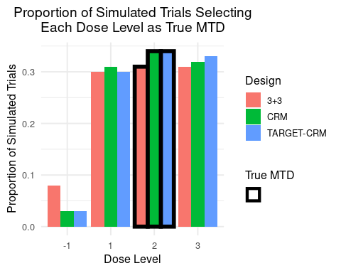
Figure 1: Proportion of simulated trials selecting each dose level as the true MTD.
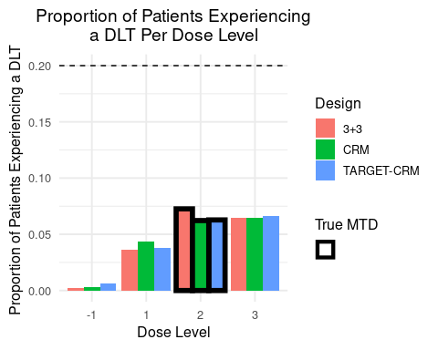
Figure 2: Proportion of patients experiencing a DLT per dose level. The target toxicity probability is denoted by the horizontal dashed line.
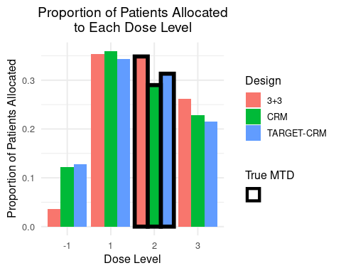
Figure 3: Proportion of simulated trials selecting each dose level as the true MTD.
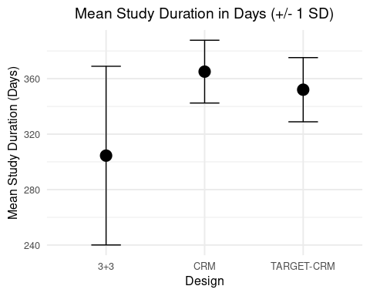
Figure 4: The mean (+/- 1 standard deviation) study duration in days.

Table 1: Summary of operating characteristics for the selected designs.
Operating Characteristic | 3+3 | TARGET-CRM | CRM
Proportion of correct selection (PCS) | 0.310 | 0.340 | 0.340
True MTD | 3.000 | 3.000 | 3.000
Proportion of trials selecting dose -1 as true MTD | 0.080 | 0.030 | 0.030
Proportion of trials selecting dose 1 as true MTD | 0.300 | 0.300 | 0.310
Proportion of trials selecting dose 2 as true MTD | 0.310 | 0.340 | 0.340
Proportion of trials selecting dose 3 as true MTD | 0.310 | 0.330 | 0.320
Proportion of patients experiencing a DLT overall | 0.176 | 0.173 | 0.173
Proportion of patients experiencing a DLT at dose -1 | 0.002 | 0.006 | 0.003
Proportion of patients experiencing a DLT at dose 1 | 0.036 | 0.038 | 0.043
Proportion of patients experiencing a DLT at dose 2 | 0.073 | 0.063 | 0.062
Proportion of patients experiencing a DLT at dose 3 | 0.065 | 0.066 | 0.065
Mean total sample size | 13.080 | 18.000 | 18.000
Minimum total sample size | 9.000 | 18.000 | 18.000
Maximum total sample size | 18.000 | 18.000 | 18.000
Proportion of patients enrolled at dose -1 | 0.037 | 0.128 | 0.122
Proportion of patients enrolled at dose 1 | 0.353 | 0.343 | 0.359
Proportion of patients enrolled at dose 2 | 0.349 | 0.313 | 0.290
Proportion of patients enrolled at dose 3 | 0.261 | 0.215 | 0.229
Mean study duration in days | 304.500 | 352.048 | 365.077
Standard deviation of study duration in days | 64.454 | 23.149 | 22.647
Mean # of cohort B patients enrolled during DLT observation period (TARGET-CRM only) | NA | 0.530 | 0.000
Standard deviation of # of cohort B patients enrolled during DLT observation period (TARGET-CRM only) | NA | 0.797 | 0.000

